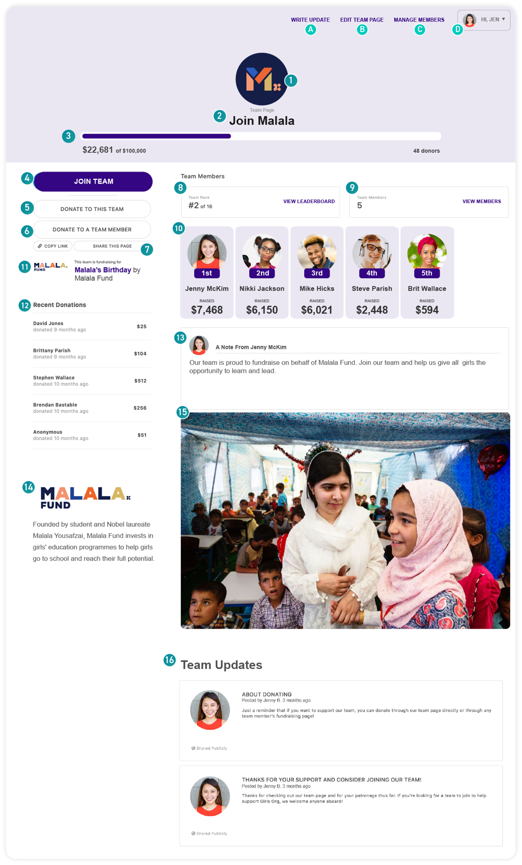


Create a GiveLively Team Page:
- Visit qrco.de/DFCAClubGive to create your School’s personalized fundraising online landing page.
- Click “I want to Fundraise to Fundraise for this”

- Select “Create a Team”
- Create a GiveLively account and confirm your email address
- Add your School’s Name
- Personalize your page by adding your school color, pictures or videos, your fundraising goals (these can be changed later) and a description. Your description can include why highlights from your Club, the successes your school’s experienced with DFCA, or simply the impact community members can have by making a gift.
- Don’t forget to grab your unique URL for your School’s GiveLively landing page so you can share it with your community page.
Overview of GiveLively Team Page:
- School Icon (Team Icon)
* Can be uploaded by the Coordinator (or team leader).
* If nothing is uploaded, DFCA’s campaign logo will automatically appear.
* Recommended minimum size: 640 x 640 pixels (1:1) - supported file types: JPG, PNG
- School Name (Team Name)
* Set when creating the Team Page. (It can be changed until the first donation is received or the first team member joins).
- School Fundraising Goal, Progress Meter and Donor Count
* Set by the Coordinator and can be changed at any time. This will be automatically updated after each gift received by the team. These numbers will also roll up to the main DFCA Campaign Page for a collective total across all participating Clubs.
- Join Team Button
* Launches the process by which parents, community members, other staff, etc. can join a School’s team and fundraise on the School’s behalf. (Teams are open for anyone to join.)
- Donate to This Team Button
* Allows donors to donate to the team page directly.
- Donate to a Team Member Button
* Links to a page showcasing all of the members of a team. Donations can be made to a specific team member or the whole team.
- Social Sharing Buttons
* Opens a tool that allows donors to share the donation page via Facebook, Twitter or email.
- Team Leaderboard
* Shows Schools rank against other Schools.
* Provides a direct link to the Leaderboard, which lists — and provides more detail about — all of the individual fundraisers and teams.
- Team Members
* Shows how many Schools are participating in the fundraiser.
- Team Member Cards (sorted by amount raised)
* Shows all members of School, with their images, names and amounts raised.
- DFCA Main Campaign Page
* Donations toward School’s goals also count automatically toward DFCA overall fundraising totals.
- Recent Donations
* Shows up to 5 of the most recent donations made to any team member or directly to the team.
- Team Leader Note
* Carries a note from the team leader. The default note already in place can be edited any time the team leader feels ready or able to personalize it.
- Logo and Description
- Primary Media (Image/Video)
* Chosen by the team leader from the following options:
- upload an own image (supported file types JPG and PNG; recommended dimensions: 2000 x 1200 pixels), which can be edited to fit the 5:3 aspect ratio using a built-in image sizer and cropper
- paste in a link to a video
- Team Updates
* Written by the team leader. See note A ("Write an Update") below.
* Notes can also be sent via email directly to team members.
* Privacy settings: Some notes can only be seen by logged-in team members, while others can be seen publicly.

